

Computer Engineering Department
Course name: Web Technologies
Course code: 2CP08
Faculty: Prof Kirtikumar Sharma

ID: 23CP029
Name: Viral Vipulkumar Bhoi
Topic: Report of LAB - 4

LAB 3: Cascading Style Sheets (CSS): Create Mypage.html using an external style sheet. Adding CSS: External, Internal and Inline

TABLE OF CONTENT:

4.1 Cascading Style Sheets (CSS). . . . . . . . . . . . . . . . . . . . . . . . . . . . . . . . . . . . . . . . . . . . . . . . . 3
4.2 HTML code for Mypage . . . . . . . . . . . . . . . . . . . . . . . . . . . . . . . . . . . . . . . . . . . . . . . . . . . 4
4.3 CSS code for Mypage . . . . . . . . . . . . . . . . . . . . . . . . . . . . . . . . . . . . . . . . . . . . . . . . . . . . . 7
4.4 Output . . . . . . . . . . . . . . . . . . . . . . . . . . . . . . . . . . . . . . . . . . . . . . . . . . . . . . . . . . . . . . . . . 9
4.5 Q1 . . . . . . . . . . . . . . . . . . . . . . . . . . . . . . . . . . . . . . . . . . . . . . . . . . . . . . . . . . . . . . . . . . . . 10
4.6 Q2 . . . . . . . . . . . . . . . . . . . . . . . . . . . . . . . . . . . . . . . . . . . . . . . . . . . . . . . . . . . . . . . . . . . . 11

4.1 CSS And html Tags ::

- ID:
  - The id attribute is used in HTML to assign a unique identifier to an element
  - Same id cannot be given to more than one element.
- Class:
  - a class is an attribute used to group multiple elements.
- <link>:
  - It is used to define a relationship between the current document and an external resource.
- CSS:
  - CSS (cascading stylesheet) used to define overall looks of webpage, three ways to include : inline, internal and external.
- CSS block:
  - selector { property: value; }.
- Select by element name:
  - Ele_name { property: value;}.
- Select by element id:
  - #id_name { property: value;}.
- Select by element class:
  - .id_name { property: value;}.
- Pseudo class:
  - A pseudo-class targets elements based on their state or behaviour.
  - selector:pseudo-class { property: value; }
  - e.g. hover , nth-child, first-child, last-child etc.
- Pseudo element:
  - A pseudo-element allows you to style specific parts of an element.
  - selector::pseudo-element { property: value; }
  - e.g. before, after, first-letter, etc.
- <Style>:
  - Used for internal CSS. Defined inside head tag.

4.2 HTML code for Mypage:

<!DOCTYPE html>
<html>
<head>
<title> Mypage </title>
<link rel="stylesheet" href="style.css">
</head>

<body>
<h1> working with css </h1>
<p> this is a random paragraph. this is a random paragraph. this is a random paragraph. this is a random paragraph. this is a random paragraph. this is a random paragraph. </p>

<table>
<tr>
<th> roll no. </th>
<th> sub-1 </th>
<th> sub-2 </th>
</tr>
<tr>
<td> 1001 </td>
<td> 45 </td>
<td> 38 </td>
</tr>
<tr>
<td> 1002 </td>
<td> 35 </td>
<td> 39 </td>
</tr>
<tr>
<td> 1003 </td>
<td> 40 </td>
<td> 40 </td>
</tr>
<tr>
<td> 1004 </td>
<td> 49 </td>
<td> 32 </td>
</tr>
<tr>
<td> 1005 </td>
<td> 30 </td>
<td> 32 </td>
</tr>
</table>

<h2> Example of list </h2>
<ul>
<li> item-1 </li>
<li> item-2 </li>
<li> item-3 </li>
<li> item-4 </li>
<li> item-5 </li>
</ul>

<div class = "style">
This text is styled with some of the text formatting properties. The heading uses the text-align, text-transform, and color properties. The paragraph is indented, aligned, and the space between characters is specified. The underline is removed from this colored "Try it Yourself" link.
</div>

<h3>
<a href="https://www.google.com"> Google </a>
<a href="https://www.Youtube.com"> Youtube </a>
<a href="https://www.linkedin.com"> LinkedIn </a>
<a href="https://www.leetcode.com"> LeetCode </a>
<a href="https://www.w3schools.com"> W3schools </a>

</body>
</html>

4.3 CSS code for Mypage:

body{
background-color : red;
}
h1, h2, h3, h4, h5, h6{
font-size: 150%;
}
p{
font-weight : bold;
font-family : Arial;
}
.style{
text-transform: capitalize;
text-decoration-line: underline;
text-indent: 1cm;
}
ul{
list-style-type: circle;
}
li{
border-top: 2px solid black;
border-right: 2px solid black;
margin: 1cm;
font-size : 22px;
}
a{
padding : 15px;
text-decoration : none;
}
a:visited {
color: white;
}
a:hover{
color : green;
background-color : yellow;
}
a:active {
color: green;
}
table{
width : 80%;
border-collapse: collapse;
text-align:center;
font-family : Verdana;
margin: auto;
border: 4px solid black;
}
td,th{
border-bottom: 1px solid #000;
padding: 7px;
}
th{
background-color:DodgerBlue;
}
tr:nth-child(even) {
background-color: hsl(185, 57%, 91%);
}
tr:nth-child(odd) {
background-color: #fff;
}

4.4 Output:

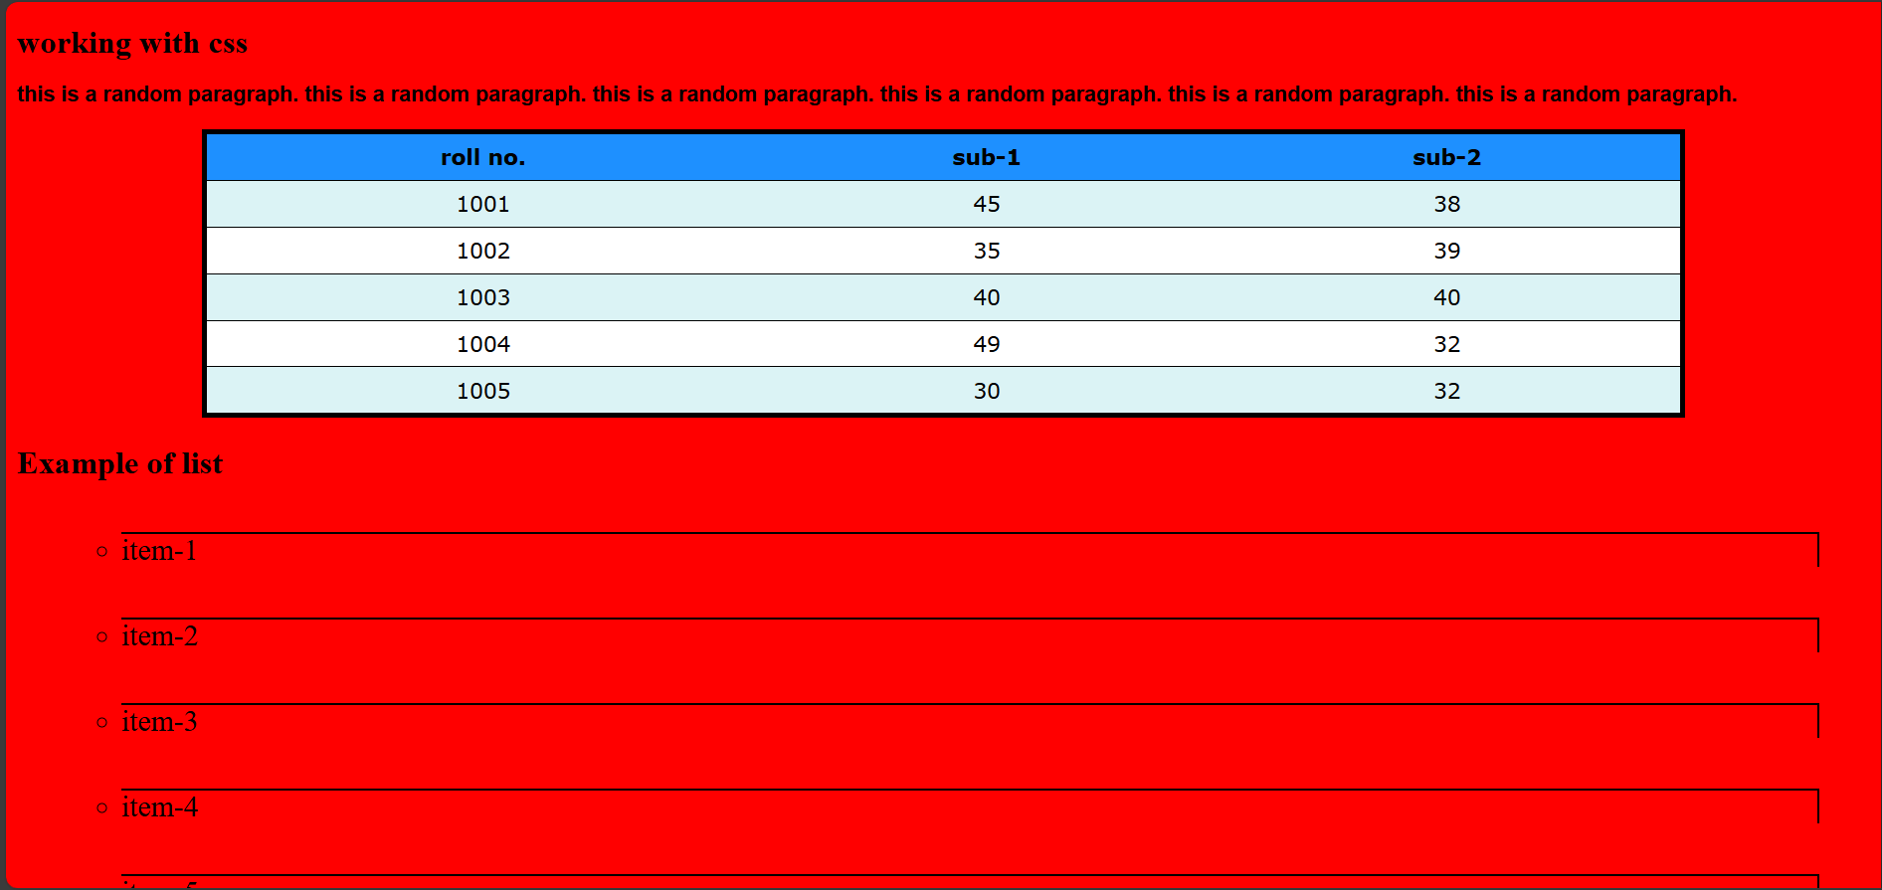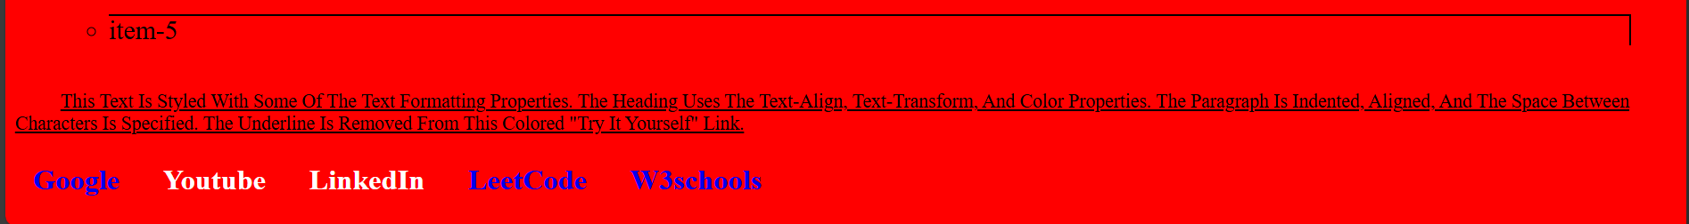

4.5 Q1:
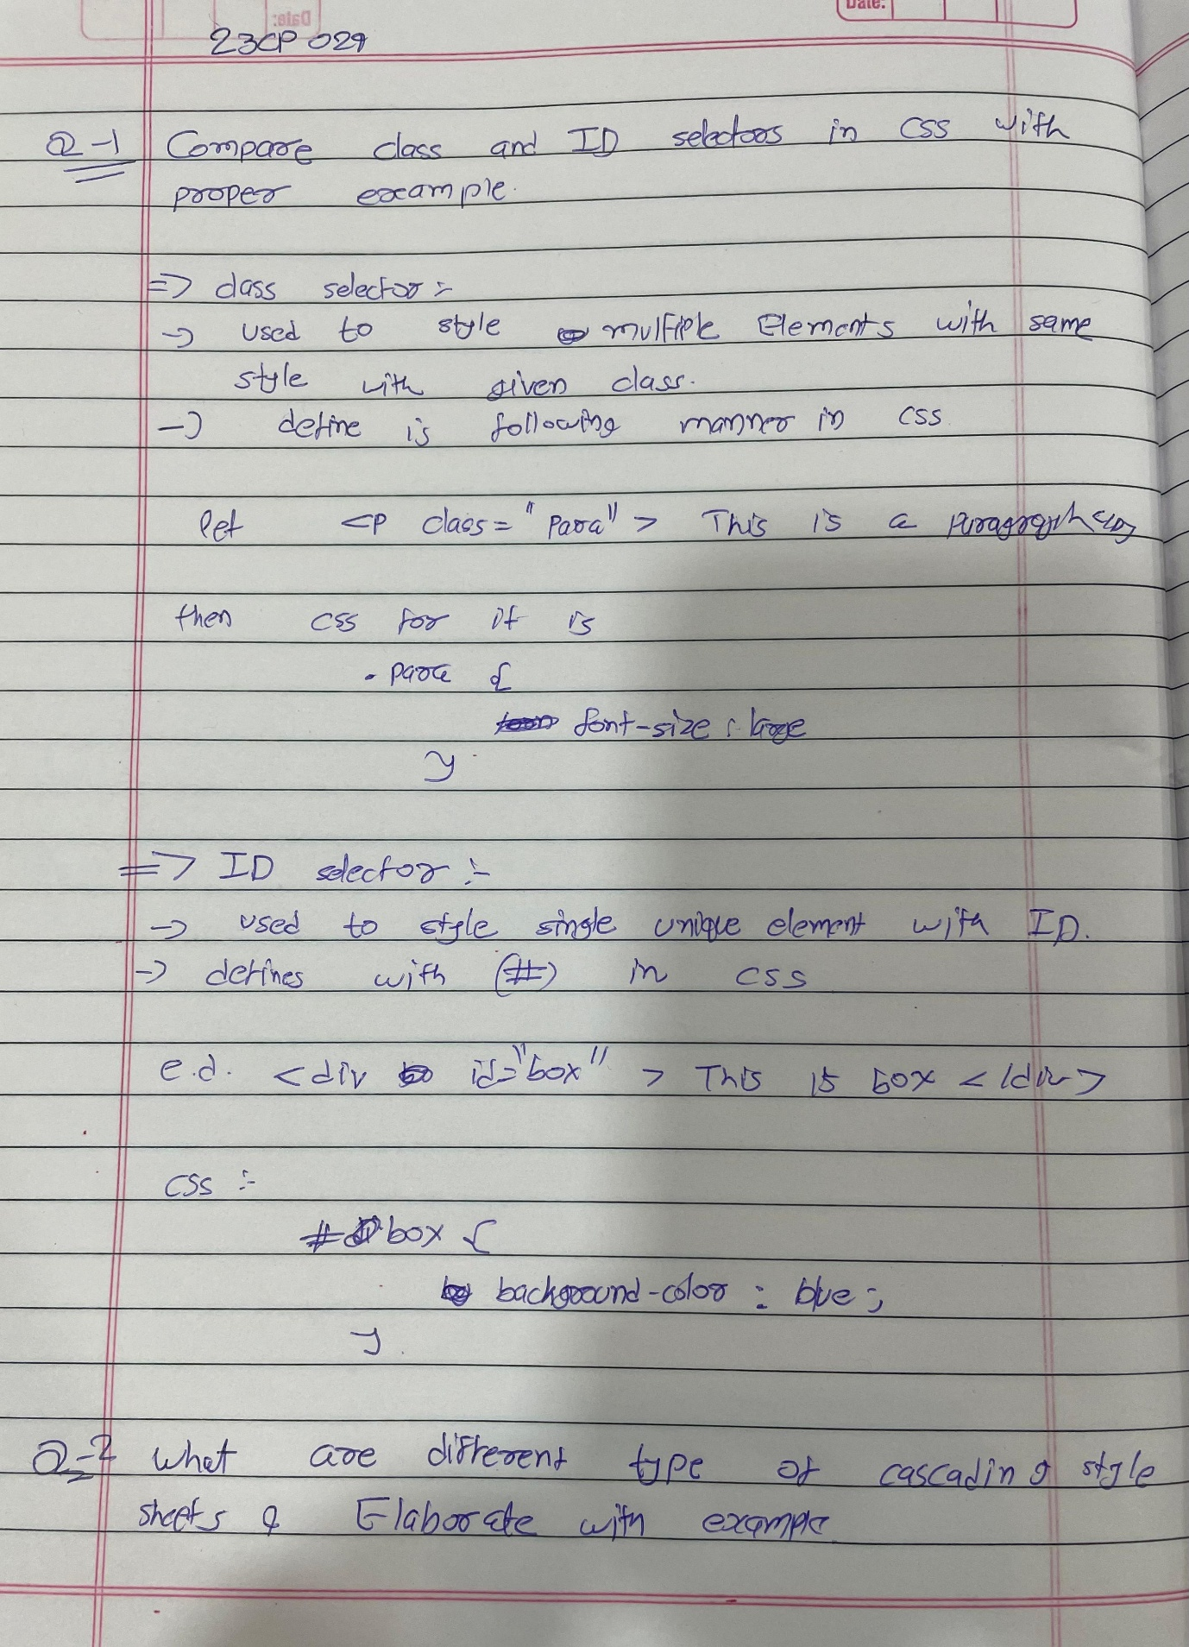

4.6 Q2:
